LAB EXPERIMENT

SET 27: PATIENT HEALTH RISK ANALYSIS

Department | AIDS
Course Code / Course Name | DSA0602 / Data Handling and Visualization
Experiment | Data Visualization using R and Tableau
Name | D.HEMASREE
Register Number | 192524114
Date | 20 October 2026
Day | Tuesday

Aim
To analyze patient health data (Age, BMI, BP and Cholesterol) using a scatterplot matrix, a Q-Q plot, an ECDF and a bar chart in R, and to build an interactive risk dashboard with a heatmap and an Age filter using Tableau.

Dataset: Patient Health Risk Analysis

Patient_ID | Age | BMI | BP | Cholesterol
P1 | 25 | 22 | 120 | 180
P2 | 40 | 28 | 135 | 210
P3 | 55 | 30 | 145 | 240
P4 | 35 | 26 | 130 | 200
P5 | 60 | 32 | 150 | 260

PROGRAM 1: Scatterplot Matrix of Health Indicators
Using R, create a scatterplot matrix for Age, BMI, BP and Cholesterol. Examine pairwise relationships to identify strong correlations, clusters or potential risk patterns.
# Dataset
patients <- data.frame(
Patient_ID = c("P1", "P2", "P3", "P4", "P5"), Age = c(25, 40, 55, 35, 60),
BMI = c(22, 28, 30, 26, 32),
BP = c(120, 135, 145, 130, 150),
Cholesterol = c(180, 210, 240, 200, 260)
)
vars <- patients[, c("Age", "BMI", "BP", "Cholesterol")]

# Scatterplot matrix pairs(vars,
main = "Scatterplot Matrix of Patient Health Indicators", pch = 1, cex = 1.3)

# Correlation matrix print(round(cor(vars), 3))

OUTPUT:
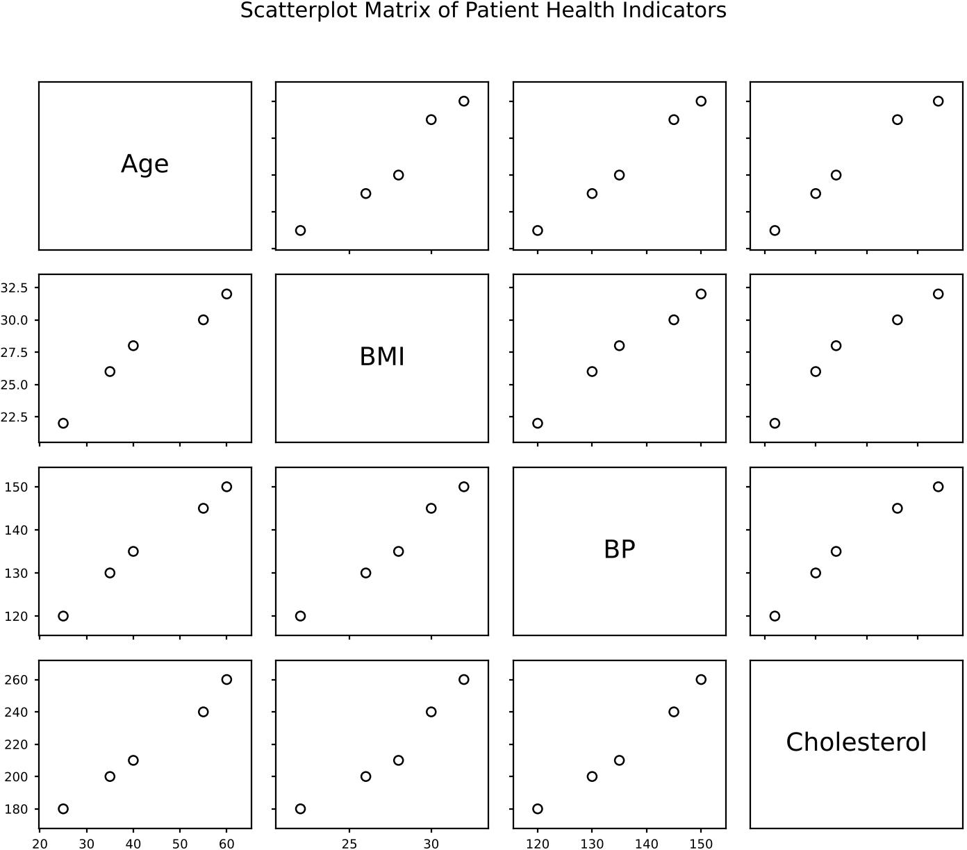
Output 1a: Scatterplot Matrix of Age, BMI, BP and Cholesterol

Console Output
Age BMI BP Cholesterol
Age 1.000 0.974 0.996
BMI 0.974 1.000 0.991
BP 0.996 0.991 1.000
Cholesterol 0.994 0.969 0.990
0.994
0.969
0.990
1.000
Output 1b: Correlation Matrix (R Console)

Observation:
Every pair of indicators shows a strong positive linear relationship, with correlations between 0.969 and 0.996. The strongest are Age and BP (0.996) and Age and Cholesterol (0.994); the weakest is BMI and Cholesterol (0.969), which is still very high. The points fall into two loose groups: P1, P4 and P2 sit at the lower left (younger, lower readings), while P3 and P5 sit at the upper right, separated by a clear gap after P2. This points to a risk pattern where older patients are high on all four indicators together. With only five patients these correlations are indicative, not proof, and they do not show cause and effect.

PROGRAM 2: Q-Q Plot and ECDF of Cholesterol
Construct a Q-Q plot and an ECDF for Cholesterol levels to assess the distribution behaviour. Comment on the normality assumption and skewness.
chol <- patients$Cholesterol par(mfrow = c(1, 2))
# Normal Q-Q plot
qqnorm(chol, main = "Normal Q-Q Plot of Cholesterol", pch = 1) qqline(chol, col = "red", lwd = 2)

# Empirical cumulative distribution function plot(ecdf(chol), main = "ECDF of Cholesterol",
xlab = "Cholesterol", ylab = "Fn(x)", col = "steelblue", lwd = 2)

par(mfrow = c(1, 1))

# Normality test and skewness shapiro.test(chol)
skew <- mean((chol - mean(chol))^3) / (mean((chol - mean(chol))^2))^(3/2) cat("Skewness:", round(skew, 4), "\n")

OUTPUT:
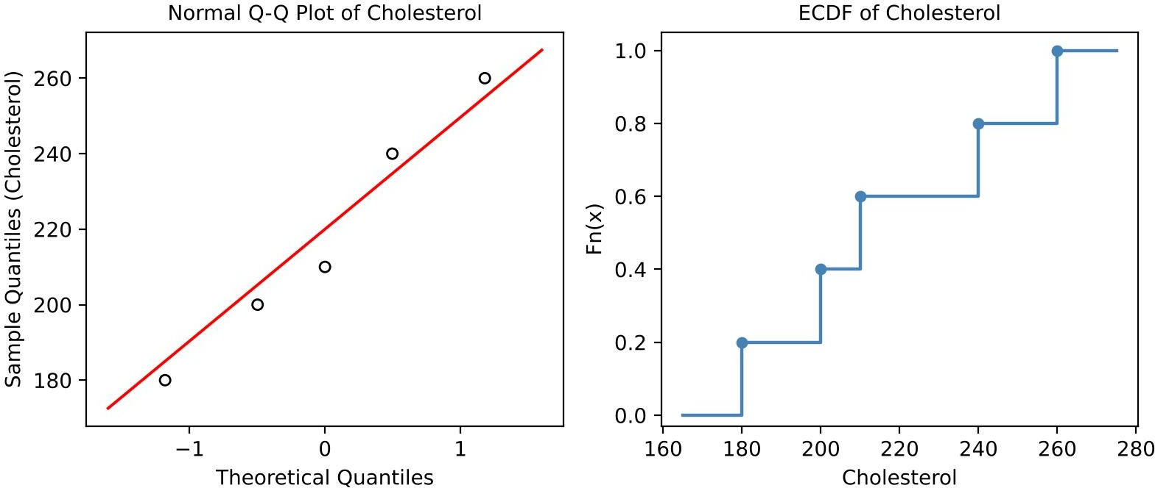
Output 2a: Normal Q-Q Plot and ECDF of Cholesterol

Console Output
Shapiro-Wilk normality test

data: chol
W = 0.96741, p-value = 0.8584

Skewness: 0.2018
Output 2b: Shapiro-Wilk Test and Skewness (R Console)

Observation:
The points in the Q-Q plot lie close to the red reference line, so the cholesterol values are consistent with a normal distribution. The Shapiro-Wilk test supports this (W = 0.967, p = 0.858, which is above 0.05), so normality is not rejected. The skewness is +0.20, a very slight right skew, which agrees with the mean (218) being a little above the median (210) and with the ECDF, which has a longer step on the high side between 210 and 240. With only five observations the test has little power, so the normality assumption should be confirmed on a larger sample.

PROGRAM 3: Bar Chart of Average Health Indicators
Using R, create a bar chart showing the average values of each health indicator (Age, BMI, BP, Cholesterol). Include axis labels, a descriptive title and distinct colors for each bar. How do these averages relate to general patient health risk?
# Average of each indicator
avg <- colMeans(patients[, c("Age", "BMI", "BP", "Cholesterol")]) print(avg)

# Bar chart
bp <- barplot(avg,
col = c("steelblue", "darkorange", "forestgreen", "firebrick"), xlab = "Health Indicator",
ylab = "Average Value",
main = "Average Health Indicator Values of Patients", ylim = c(0, 250))
text(bp, avg + 8, labels = avg)

Console Output
Age
43.0
BMI
27.6
BP Cholesterol
136.0
218.0

OUTPUT:

Observation:
Output 3a: Average Values (R Console)

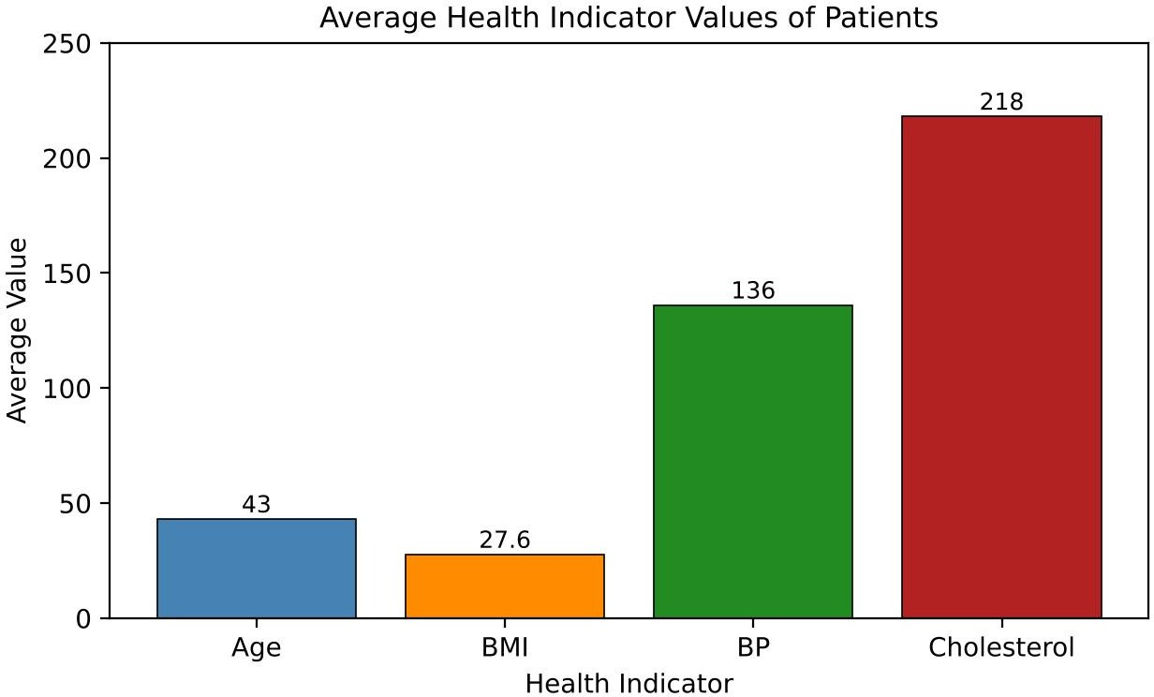
Output 3b: Average Health Indicator Values (Bar Chart)

The average patient is 43 years old with a BMI of 27.6, a BP of 136 and a cholesterol of 218. The bars use different units, so their heights show the size of each reading, not the level of risk. Compared with commonly used reference ranges, the average BMI (27.6) is in the overweight range (25 to 29.9), the average BP (136, taken as systolic) is in the Stage 1 hypertension range (130 to 139), and the average cholesterol (218) is borderline high (200 to 239). All three are above the healthy range, so the group as a whole carries a moderate to elevated health risk, and the individual patients need to be checked against the thresholds.

PROGRAM 4: Interactive Patient Risk Dashboard in Tableau
Create an interactive Tableau dashboard with a heatmap highlighting high-risk patients and an Age filter for exploring risk patterns. Include hover tooltips showing all health indicators. Analyze which patients are highest risk, how age affects risk, and how the dashboard can aid healthcare professionals in prioritizing care.

Steps in Tableau
- Save the data as an Excel or CSV file and connect to it in Tableau (Connect > Microsoft Excel / Text file). Patient_ID is the dimension; Age, BMI, BP and Cholesterol are the measures.
- Create the calculated field "Risk Score" (Analysis > Create Calculated Field) as the average of the four indicators, each scaled from 0 to 1: ([Age] - {FIXED : MIN([Age])}) / ({FIXED : MAX([Age])} - {FIXED : MIN([Age])}), plus the same expression for BMI, BP and Cholesterol, with the sum divided by 4.
- Create the calculated field "Risk Category": IF [Risk Score] >= 0.7 THEN "High" ELSEIF [Risk Score] >= 0.3 THEN "Medium" ELSE "Low" END.
- Sheet 1 (Heatmap): Drag Patient_ID to Rows and Measure Names to Columns, and keep only Age, BMI, BP and Cholesterol in the Measure Names filter. Drag Measure Values to Text, change the Marks type to Square, and drag Risk Score to Color (orange to red palette). Rename the sheet "Risk Heatmap".
- Hover tooltips: Drag Age, BMI, BP, Cholesterol, Risk Score and Risk Category to Tooltip. Click Tooltip and write: Patient: <Patient_ID>, Age: <Age>, BMI: <BMI>, BP: <BP>, Cholesterol: <Cholesterol>, Risk: <Risk Category>.
- Sheet 2 (Bar): Drag Patient_ID to Rows and Risk Score to Columns, drag Risk Category to Color, and sort in descending order. Rename the sheet "Risk Score by Patient".
- Age filter: Drag Age to Filters, choose the range of values, then right-click the filter, choose Show Filter, and set Apply to Worksheets > All Using This Data Source. Use the slider style.

- Create a new Dashboard (Dashboard > New Dashboard), set the size to Automatic, and drag both sheets and the Age filter onto it. Select the heatmap and click Use as Filter.
- Add the title "Patient Health Risk Dashboard", then test the Age slider and the hover tooltips in Presentation Mode.

OUTPUT:
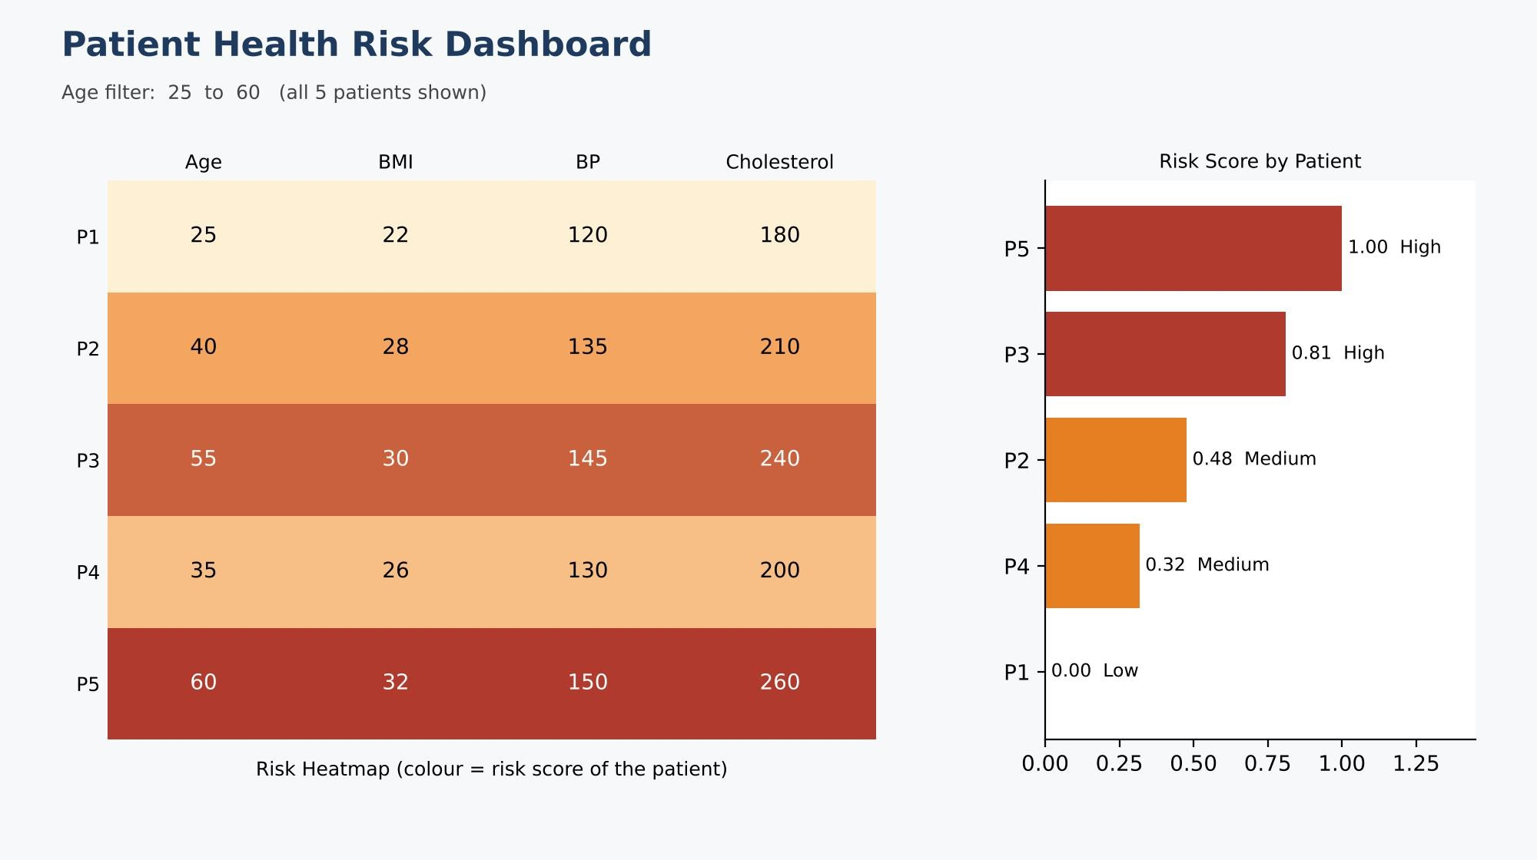
Output 4: Interactive Patient Health Risk Dashboard (Tableau)

Observation:
The heatmap and the risk-score bars show that P5 (score 1.00) and P3 (score 0.81) are the highest-risk patients and fall in the High category. Both have BMI of 30 or more (obese), BP of 145 or more (Stage 2 hypertension) and cholesterol of 240 or more (high). P2 (0.48) and P4 (0.32) are Medium risk, and P1 (0.00) is Low risk. Risk rises with age in this data: ordered by age (25, 35, 40, 55, 60), the patients have risk scores of 0.00, 0.32, 0.48, 0.81 and 1.00, so the Age filter lets users focus on older groups, although five patients are too few to claim a general trend. The dashboard helps healthcare professionals by sorting patients by risk so the High patients can be seen and treated first, showing all four readings in one hover tooltip without opening each record, and letting them narrow the view by age. The risk score is a simple unweighted average and is a screening aid, not a clinical diagnosis.

Procedure
- Define the patient data in R as a data frame and select the Age, BMI, BP and Cholesterol columns.
- Use pairs() to draw the scatterplot matrix and cor() to calculate the pairwise correlations.
- Use qqnorm(), qqline() and plot(ecdf()) for the Q-Q plot and ECDF of Cholesterol, and shapiro.test() with a skewness formula to check normality.
- Calculate the averages with colMeans() and draw the bar chart with barplot() using distinct colors and labels.
- Load the patient file into Tableau and create the Risk Score and Risk Category calculated fields.
- Build the heatmap with Measure Names and Measure Values, add tooltips, and build the risk score bar chart.
- Add the Age filter, combine the sheets in a dashboard, and add filter actions for interactivity.

RESULT:
The patient health data was successfully analyzed in R using a scatterplot matrix, a Q-Q plot with an ECDF, and a bar chart of the average indicators. The indicators were strongly and positively correlated, cholesterol was close to normally distributed with a slight right skew, and the averages were above healthy ranges for BMI, BP and cholesterol. An interactive Tableau dashboard with a risk heatmap, hover tooltips and an Age filter was also created, identifying P5 and P3 as the highest-risk patients.

Key Functions and Tools Used

Function / Tool | Purpose
data.frame() | Creates the patient data table.
pairs() / cor() | Draws the scatterplot matrix and calculates the correlations.
qqnorm() / qqline() | Draws the normal Q-Q plot with a reference line.
ecdf() / shapiro.test() | Draws the ECDF and tests the normality of Cholesterol.
colMeans() / barplot() | Calculates the averages and draws the bar chart.
Tableau Calculated Field (FIXED) | Calculates the scaled Risk Score and the Risk Category.
Tableau Heatmap (Square mark) | Highlights high-risk patients by color.
Tableau Filter / Dashboard | Adds the Age filter, tooltips and interactivity.

